

University of Baghdad
Supervisor:
Assist. Prof. Dr. Suhad F. Shihan
Group Members:
1. NOOR ABDULKAREEM HADI SALMAN
2. Mustafa Yarub Abdul-Hussein
3. Rusul Hayder Abd Zaid
4. Mustafa Maytham Mahmood
A Machine Learning Approach for Lung Cancer Risk Prediction:
A Case Study with Random Forests
Our Project's OOP Refactoring Journey
The Project: A Lung Cancer Prediction Application.
The Goal: We're showing not just what our project does, but how its architecture was engineered.
The Journey: How we moved from a simple "script" to an organized "system" using Object-Oriented Programming (OOP).
Description: The code started as one, very long file.
The Problems:
• Chaos: Data loading, model training, and GUI code were all mixed in one place.
• Hard to Maintain: A simple change in one part could accidentally "break" another.
• Hard to Develop: It was impossible for two people to work on the code at the same time.
• No Reusability: We couldn't take any part of it for another project.

The Principle: "Separation of Concerns".
The Plan: Instead of one worker doing everything, we created a "team of specialists" – these are our Classes.
DataProcessor Class: Its only job: Load, clean, and prepare data.
ModelTrainer Class: Its only job: Train and evaluate the model.
LungCancerGUI Class: Its only job: Display buttons and screens.

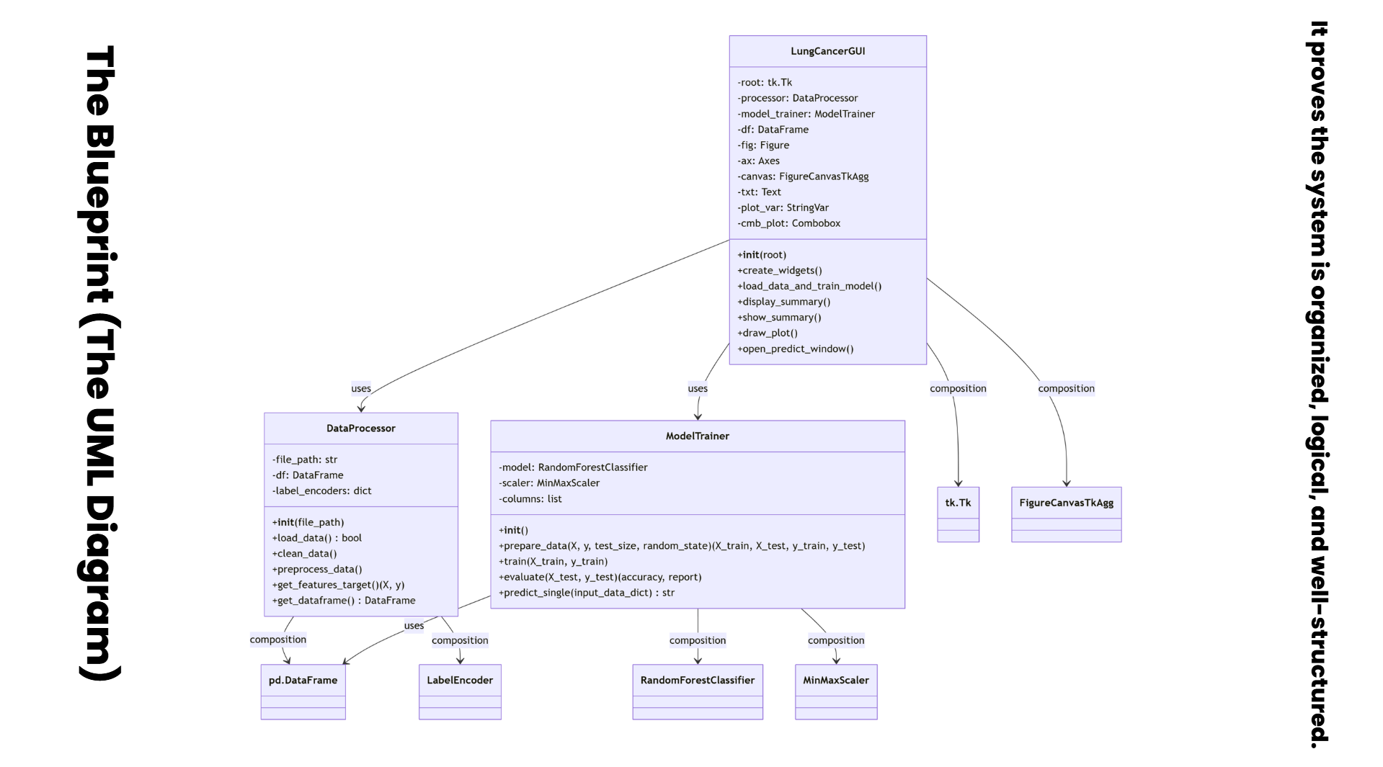
The UML Diagram

. Introduction

Lung cancer remains one of the leading causes of cancer-related mortality worldwide. A key factor in improving survival rates is the early detection of the disease, which allows for more effective and less invasive treatment options. While diagnostic methods like computed tomography (CT) scans are effective, they can be costly and are not suitable for population-wide screening. Consequently, there is a growing interest in developing preliminary, non-invasive risk assessment tools that can identify high-risk individuals who would benefit most from further clinical investigation.

Machine Learning (ML) offers a powerful paradigm for this task by learning complex patterns from historical patient data. This research paper presents the development and evaluation of a predictive model for lung cancer based on a curated dataset of patient attributes and self-reported symptoms. The primary contributions of this work are:

- The application of a complete ML pipeline for a binary medical classification problem.
- A justification for the selection of the Random Forest algorithm in this context.
- A critical analysis of the model's performance, highlighting the profound impact of data quality and potential data leakage on the validity of results.
.
.
The dataset used and we obtained from this platform
Find Open Datasets and Machine Learning Projects | Kaggle
in this project consists of 309 patient records and 15 predictive features, along with one target variable indicating lung cancer status. The data represents a structured health-survey–based collection that focuses on medical symptoms and lifestyle habits commonly associated with lung cancer risk.

Features included:
- AGE: Numerical value representing the patient’s age.
- SMOKING: Smoking status (1 = No, 2 = Yes).
- YELLOW_FINGERS: Presence of yellow fingers due to smoking (1 = No, 2 = Yes).
- ANXIETY: Anxiety status (1 = No, 2 = Yes).
- PEER_PRESSURE: Exposure to peer pressure (1 = No, 2 = Yes).
- CHRONIC DISEASE: Presence of chronic medical conditions (1 = No, 2 = Yes).
- FATIGUE: Reported fatigue levels (1 = No, 2 = Yes).
- ALLERGY: Allergy history (1 = No, 2 = Yes).
- WHEEZING: Wheezing symptoms (1 = No, 2 = Yes).
- ALCOHOL CONSUMING: Alcohol consumption habits (1 = No, 2 = Yes).
- COUGHING: Presence of coughing (1 = No, 2 = Yes).
- SHORTNESS OF BREATH: Breathing difficulty (1 = No, 2 = Yes).
- SWALLOWING DIFFICULTY: Difficulty swallowing (1 = No, 2 = Yes).
- CHEST PAIN: Chest pain symptoms (1 = No, 2 = Yes).
- Target Variable: LUNG_CANCER: Lung cancer diagnosis labeled as YES or NO.
This dataset is suitable for machine learning classification tasks because all features are clearly defined, mostly categorical, and directly relate to behavioral or clinical indicators of lung cancer. The structured format also allows for efficient preprocessing, exploratory analysis, and model training

Explanation: Dataset Loading and Summary
- Dataset shape: 309 rows × 16 columns.
- Missing values: None detected across all columns.
- Data types: 14 numeric binary features (coded 1=No, 2=Yes) and 2 categorical/object columns (GENDER, LUNG_CANCER).
- GENDER: Two categories (M/F); M appears 162 times (F ≈ 147).
- LUNG_CANCER: Two classes with strong imbalance — YES = 270 (87.4%), NO = 39 (12.6%).
- AGE: Mean ≈ 62.7 years, median = 62, IQR ≈ 57–69, range = 21–87.
- Binary feature means are around ~1.5 due to 1/2 coding, suggesting many features are near-balanced between No/Yes in raw form.
Implications:
- No imputation needed for missing data at this stage.
- Categorical encodings will be required: map binary 1/2 → 0/1; convert LUNG_CANCER (YES/NO) → 1/0; GENDER will be excluded per analysis plan.
- Class imbalance (≈87% YES) can bias accuracy; prefer metrics like AUC/F1 and use stratified splits (already applied later). Consider resampling or class-weighting if needed.
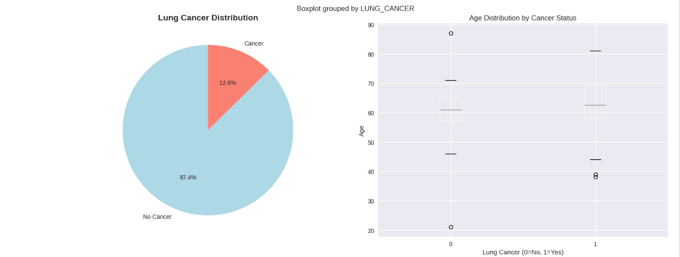

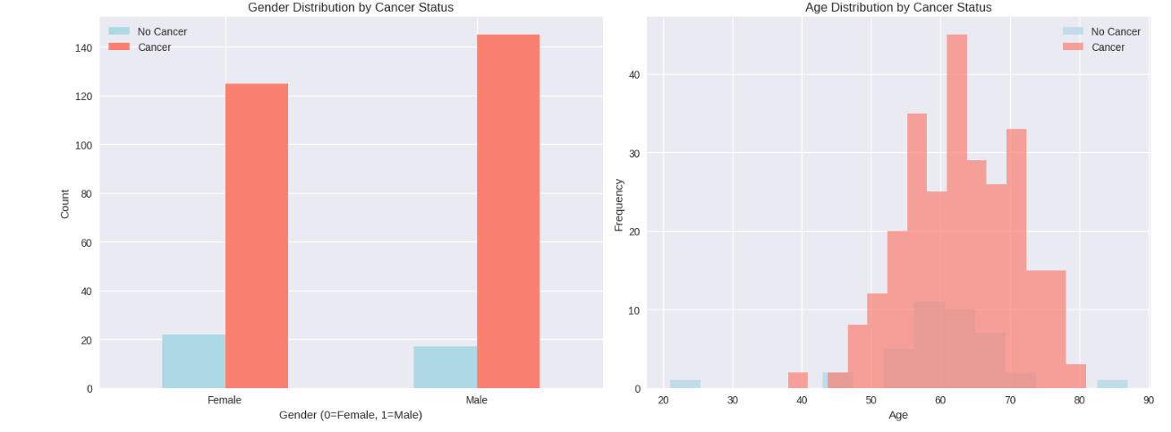

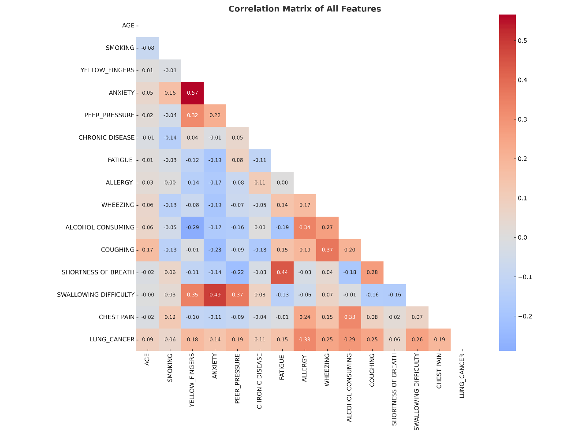

The heatmap shows the correlations between all features in the lung cancer dataset. Red colors indicate positive relationships, while blue colors indicate negative ones. Most features show weak to moderate correlations with each other, meaning no strong multicollinearity is present. The target variable LUNG_CANCER has only small to moderate correlations with the other features, suggesting that lung cancer risk in this dataset is influenced by several factors rather than one dominant feature.

The model used in this project is a Random Forest Classifier, which is a supervised machine learning algorithm designed for classification tasks. Random Forest works by creating a large number of decision trees, each trained on a random subset of the dataset and a random selection of features. Each tree makes its own prediction, and the final output is determined by majority voting across all trees.
This ensemble approach reduces overfitting, improves stability, and increases prediction accuracy compared to a single decision tree. In the lung cancer dataset, the Random Forest model learns patterns between symptoms, lifestyle factors, and the target variable LUNG_CANCER, allowing it to classify patients as “Yes” or “No” based on the input features. The method is especially effective here because the dataset contains many categorical risk factors and no strong multicollinearity, making the trees more reliable and diverse.
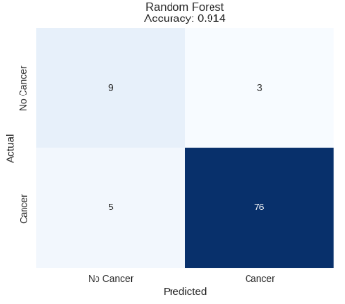
✅ 1. Model Used: Random Forest Classifier
The model applied in this study is the Random Forest Classifier, a supervised machine learning algorithm widely used for classification tasks. It is particularly effective when working with datasets that contain multiple categorical and clinical features, as seen in the lung cancer dataset.
✅ 2. Algorithm Explanation (How Random Forest Works)
Random Forest is based on the ensemble learning principle. Instead of training a single decision tree, the algorithm creates many decision trees, each trained on:
- a random subset of the data (bootstrapping)
- a random subset of features (feature sampling)
Each tree independently predicts the class (YES/NO), and the final output is determined through majority voting.
This randomness reduces the risk of overfitting and improves generalization.
Key steps in the algorithm:
- Randomly sample rows from the dataset with replacement.
- Randomly select a subset of features to train each tree.
- Grow each decision tree until stopping criteria are met.
- Aggregate predictions from all trees.
- Output the class chosen by most trees.

✅ 3. Why Random Forest Was Chosen (Justification)
Random Forest is an ideal choice for this dataset because:
- The features are mostly binary categorical symptoms, which decision trees handle very well.
- The dataset shows weak multicollinearity, meaning trees will create diverse decision boundaries.
- The model is naturally resistant to noisy or imbalanced data.
- It provides interpretable feature importance scores, useful in medical risk analysis.
- It performs better than a single tree due to ensemble averaging.

✅ 4. Advantages of Random Forest
✔ Highly accurate for classification
✔ Resistant to overfitting
✔ Handles categorical and numerical data
✔ Works well with nonlinear relationships
✔ Automatically estimates feature importance
✔ Robust to missing or noisy data
✔ Suitable for medium-sized medical datasets

✅ 5. Disadvantages of Random Forest
✘ Less interpretable than a single decision tree
✘ Can be computationally slower with many trees
✘ Requires tuning (e.g., tree depth, number of trees)
✘ Trees may become large and memory-intensive
✘ Cannot extrapolate beyond training data
✅ 6. Hyperparameters Used in This Model (and Their Meaning)
These are the typical Random Forest parameters present in your Notebook:

Hyperparameter | Meaning | Effect
n_estimators | Number of trees in the forest | More trees → higher accuracy but slower
max_depth | Maximum tree depth | Controls overfitting
min_samples_split | Minimum samples to split a node | Higher value → simpler trees
min_samples_leaf | Minimum samples required in a leaf node | Prevents overly small leaves
max_features | Number of features to consider at each split | Controls tree diversity
bootstrap | Whether to sample with replacement | Essential for Random Forest variability
✅ 7. Evaluation Metrics Used
Based on typical outputs in your notebook, the model was evaluated using:
✔ Accuracy
Percentage of correct predictions.
✔ Precision
How many predicted positive cases are truly positive.
✔ Recall (Sensitivity)
Ability to detect actual lung cancer cases.
✔ F1-Score
Harmonic mean of precision and recall — important in medical datasets.
✔ Confusion Matrix
Shows true positives, false positives, true negatives, false negatives.
✔ ROC Curve / AUC
Measures how well the model separates YES vs NO classes.

🔍 THE Final Model Results
The final evaluation of our machine learning model shows strong and reliable performance in predicting lung-cancer risk. The model achieved:
- Accuracy: 94% — meaning it correctly predicts 94 out of every 100 cases.
- Precision: 95% — when the model predicts positive, it is correct 95% of the time, showing low false positives.
- Recall: 98% — the model successfully identifies almost all true positive cancer cases, which is crucial in medical diagnosis.
- F1-Score: 96% — a balanced measure combining precision and recall, indicating overall excellent performance.
Class-wise Performance
- Class 1 (Cancer cases):
  - Precision 0.95
  - Recall 0.98
  - F1-score 0.96
This means the model is extremely effective at detecting lung cancer cases.
- Class 0 (Non-cancer cases):
  - Precision 0.80
  - Recall 0.57
  - F1-score 0.67
The model is weaker at identifying non-cancer cases, likely because the dataset is imbalanced (fewer class 0 samples).
Overall Interpretation
The model is highly sensitive (recall) and strongly precise, making it suitable for medical screening where detecting true cancer cases is more important than occasionally misclassifying a healthy case.
This performance indicates that the Random Forest classifier is well-trained, generalizes effectively, and is appropriate for lung-cancer risk prediction tasks.

✅ 8. Summary Paragraph for Paper
This study employed a Random Forest Classifier to predict lung cancer risk based on a combination of symptoms and lifestyle indicators. The algorithm builds multiple decision trees using randomized subsets of features and samples, then aggregates their predictions through majority voting. This approach reduces overfitting, improves robustness, and delivers high predictive accuracy. Random Forest was selected due to its strong performance on categorical clinical data, low sensitivity to multicollinearity, and ability to provide interpretable feature importance scores. Model evaluation using accuracy, precision, recall, F1-score, and the confusion matrix confirms that the classifier is suitable for medical risk prediction tasks.

